Press Release: International Port Welfare Partnership Pilot Project
A better welcome for visiting seafarers
A new website designed to encourage the formation of port welfare boards around the world to provide a welcome to visiting seafarers has been launched today by the UK based Merchant Navy Welfare Board (MNWB).
An important element in a project managed on behalf of the International Seafarers’ Welfare Assistance Network (ISWAN), the website explains the role of welfare boards, which are an integral part of the Maritime Labour Convention 2006, now being implemented around the world.
Regulation 4.4 of MLC 2006, requires member states to ensure that seafarers working on board a ship have access to shore-based facilities and services to secure their health and well-being. It recommends that in order to fulfil this requirement, member states “shall encourage the establishment of welfare boards which shall regularly review welfare facilities and services to ensure that they are appropriate in the light of changes in the needs of seafarers resulting from technical, operational and other developments in the shipping industry.”
Managed by the MNWB, the ISWAN project is designed to provide information, guidance and advice to assist in the establishment of welfare boards in parts of the world where they have not been previously seen. Additionally, the project will assess the operational effectiveness of existing welfare boards around the world, while helping to establish minimum standards and promoting best practice. It is hoped that using this information, developed within a single point of contact, a “model” might be provided that will be the basis of welfare boards thus fulfilling the objectives of MLC 2006 and leading to a major, global project.
ISWAN Executive Director, Roger Harris stated "We are pleased to have the ITF Seafarers’ Trust sponsoring and MNWB managing this important pilot project on our behalf.” He added “We now have an international Project Executive Committee that boasts cross sector representation and are looking forward to working in partnership with MNWB who possess a wealth of experience operating welfare boards.”

Peter Tomlin, Deputy Chief Executive of MNWB and Project Manager stated "Strong, effective Welfare Boards needn’t be expensive or time consuming to organise or participate in. Every port is unique and we are mindful that there is no easy ‘one size fits all’ rule for establishing Welfare Boards; however, we look forward to sharing our expertise with partners in the international maritime community. Welfare boards are capable of really supporting and improving seafarers’ welfare services in ports and this exciting pilot project captures the collaborative spirit of MLC, 2006”

Kimberly Karlshoej, Head of ITF Seafarers’ Trust stated “The Trust is very proud to be the sponsor of the Port Welfare Partnership Pilot Project. The promotion and utilisation of port welfare boards is a critical step in improving services to seafarers during their all too short stays in the world's ports”.

The project website emphasises that the successful welfare board is, like a well-functioning port welfare committee, a co-operative partnership within the maritime community. It will involve the participation of individuals and agencies such as harbourmasters, port agents, port health, seafaring unions, voluntary organisations and the welfare providers, along with local authorities. At both a national and local port level, it will also encourage financial support from the industry through port levies and donations, and seek other mechanisms for funding, where this might be required.
Designed to provide an introduction to the important topic of seafarers’ welfare, and underlining the reasons why the obligations under MLC 2006 are important, the website also shows something of the life of the modern day seafarer and why ports need to provide this essential workforce with a warm welcome, all around the world.
To access the new project website visit www.portwelfare.org

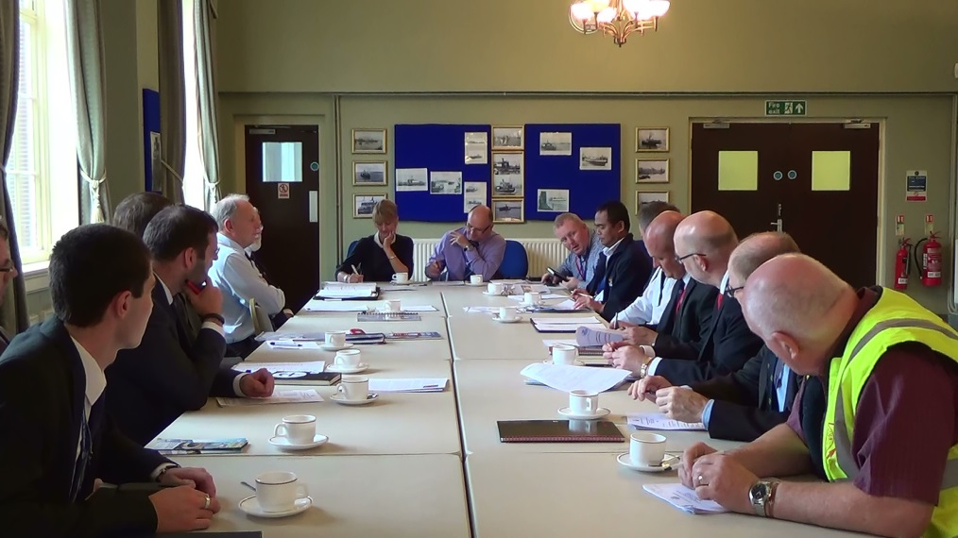
The London & South East Ports Welfare Committee, one of the UK’s welfare boards meets regularly to support and improve welfare services for domicile and visiting seafarers
Further organisational information:
ISWAN: The International Seafarers Welfare and Assistance Network promotes seafarers welfare worldwide and supports seafarers with a 24/7 helpline www.seafarerswelfare.org
MNWB: The Merchant Navy Welfare Board is the UK umbrella charity for the Merchant Navy supporting the provision of quality welfare services for seafarers and their dependants. www.mnwb.org.
ITF Seafarers’ Trust: The ITF Seafarers’ Trust provides funds for organisations who do work for the benefit of seafarers www.seafarerstrust.org
For further project information: email admin@portwelfare.org or contact:
Alastair Whitfield, Project Administrator Alastair@mnwb.org or Peter Tomlin MBE MNM, Deputy Chief Executive & Project Manager, Merchant Navy Welfare Board, 8, Cumberland Place, Southampton SO15 2BH Tel: 0044 (0) 2380 337799.

